Painting by Mary Ann Askew
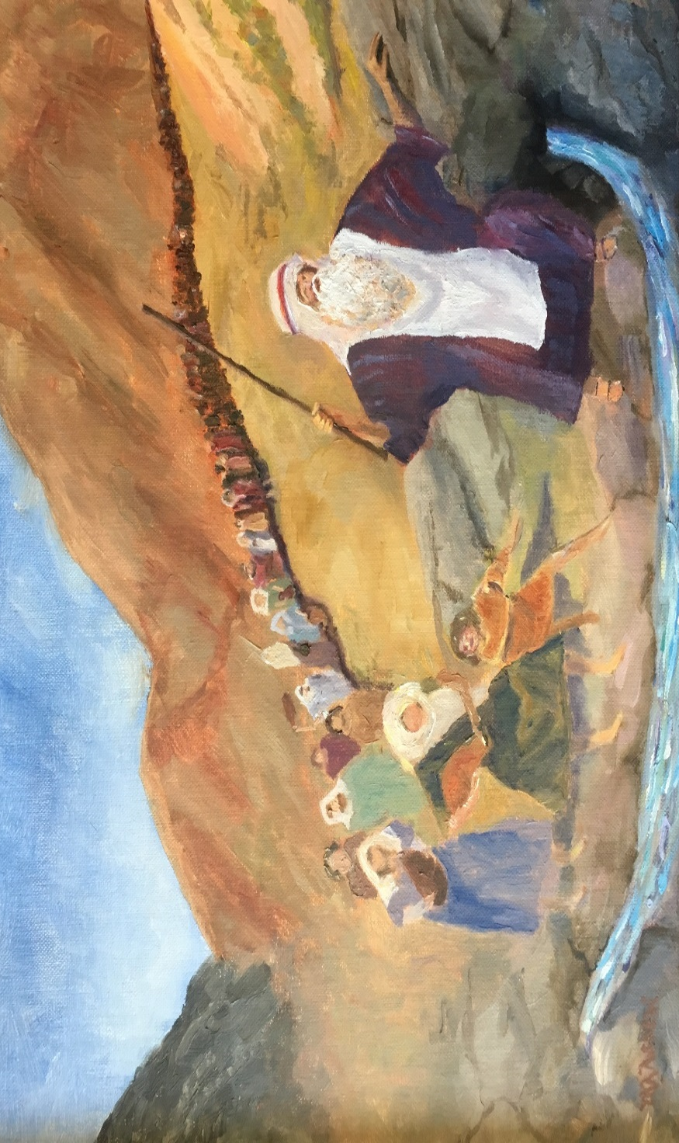
Fighting for Faith in Moments of Frustration and Failure
- Scripture Lesson
Numbers 20:2-13 (ESV)
²Now there was no water for the congregation. And they assembled themselves together against Moses and against Aaron. ³And the people quarreled with Moses and said, “Would that we had perished when our brothers perished before the Lord! ⁴Why have you brought the assembly of the Lord into this wilderness, that we should die here, both we and our cattle? ⁵And why have you made us come up out of Egypt to bring us to this evil place? It is no place for grain or figs or vines or pomegranates, and there is no water to drink.” ⁶Then Moses and Aaron went from the presence of the assembly to the entrance of the tent of meeting and fell on their faces. And the glory of the Lord appeared to them, ⁷and the Lord spoke to Moses, saying, ⁸“Take the staff, and assemble the congregation, you and Aaron your brother, and tell the rock before their eyes to yield its water. So you shall bring water out of the rock for them and give drink to the congregation and their cattle.” ⁹And Moses took the staff from before the Lord, as he commanded him. ¹⁰Then Moses and Aaron gathered the assembly together before the rock, and he said to them, “Hear now, you rebels: shall we bring water for you out of this rock?” ¹¹And Moses lifted up his hand and struck the rock with his staff twice, and water came out abundantly, and the congregation drank, and their livestock. ¹²And the Lord said to Moses and Aaron, “Because you did not believe in me, to uphold me as holy in the eyes of the people of Israel, therefore you shall not bring this assembly into the land that I have given them.” ¹³These are the waters of Meribah, where the people of Israel quarreled with the Lord, and through them he showed himself holy.

- Introduction

“Off script” - term used to describe the occasion when one ‘goes rogue’ and acts in a manner not contemplated or planned.
_____________________________________________________________________________________________________________________________________________________________________________________________________________________________________________________________________________________________________________________

- Big Idea

Our vision of God as judge and redeemer in the moment significantly impacts our response to those who frustrate and fail us.
_____________________________________________________________________________________________________________________________________________________________________________________________________________________________________________________________________________________________________________________

- Seeing our Opportunity

“Unbelief squashes; faith teaches while it directs. Faith sees what was turned aside to the service of sin and seeks to turn it back again..faith must distinguishs that which must be preserved and developed and that which mut be abandoned because of sin…takes someone aside and shows them the part of what they did that was good, while also exposing the other part of what they did that got in the way. And to say, this is a better way.”
- Doug Wilson
_______________________________________________________________________________________________________
_______________________________________________________________________________________________________
_______________________________________________________________________________________________________

- Embracing our Failure

James 4:12
¹² There is only one Lawgiver and Judge, the one who is able to save and destroy. But you—who are you to judge your neighbor?
_____________________________________________________________________________________________________
_____________________________________________________________________________________________________
_____________________________________________________________________________________________________

- Walking by Faith

Exodus 17:6
⁶ Behold, I will stand before you there on the rock at Horeb, and you shall strike the rock, and water shall come out of it, and the people will drink.

Mathew 8:13
But the centurion replied, “Lord, I am not worthy to have you come under my roof, but only say the word, and my servant will be healed.”

Matthew 21:21-22
And Jesus answered them, “Truly, I say to you, if you have faith and do not doubt, you will not only do what has been done to the fig tree, but even if you say to this mountain, ‘Be taken up and thrown into the sea,’ it will happen. ²² And whatever you ask in prayer, you will receive, if you have faith.”

John 4:10
¹⁰ Jesus answered her, “If you knew the gift of God, and who it is that is saying to you, ‘Give me a drink,’ you would have asked him, and he would have given you living water.”
_______________________________________________________________________________________________________
_______________________________________________________________________________________________________
_______________________________________________________________________________________________________

