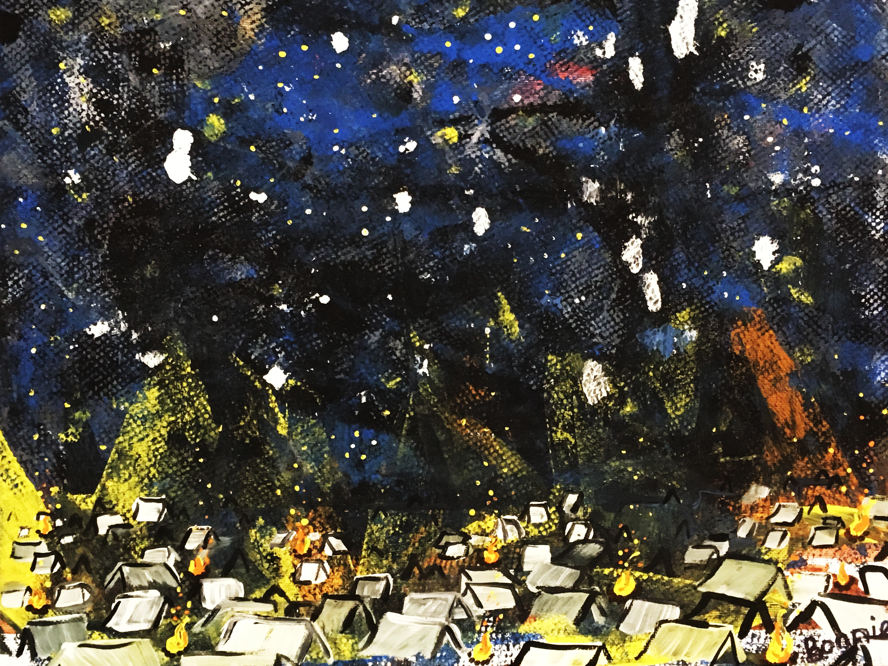
Painting by Bonnie Mitchell

Marked for Mission

- Scripture Lesson

Numbers 15:37-41 (ESV)
³⁷ The Lord said to Moses, ³⁸ “Speak to the people of Israel, and tell them to make tassels on the corners of their garments throughout their generations, and to put a cord of blue on the tassel of each corner. ³⁹ And it shall be a tassel for you to look at and remember all the commandments of the Lord, to do them, not to follow after your own heart and your own eyes, which you are inclined to whore after. ⁴⁰ So you shall remember and do all my commandments, and be holy to your God. ⁴¹ I am the Lord your God, who brought you out of the land of Egypt to be your God: I am the Lord your God.”

- Introduction

______________________________________________________________________________________________________________________________

______________________________________________________________________________________________________________________________
- Big Idea

The sacraments are an identity marker of the Church and the regular reminder of God’s faithfulness and royal calling.

______________________________________________________________________________________________________________________________

______________________________________________________________________________________________________________________________

______________________________________________________________________________________________________________________________

- Identity Marker

_________________________________________________________________________________________________________

_________________________________________________________________________________________________________

______________________________________________________________________________________________________________________________

- Regular Reminder

_________________________________________________________________________________________________________

_________________________________________________________________________________________________________

______________________________________________________________________________________________________________________________

- Conclusion

_________________________________________________________________________________________________________

_________________________________________________________________________________________________________

______________________________________________________________________________________________________________________________

Resources:
- Ashley, Timothy R. The Book of Numbers. The New International Commentary on the Old
Testament. Grand Rapids, MI: William B. Eerdmans Publishing Company, 1993.
- Brown, Raymon. The Message of Numbers. The Bible Speaks Today. Downers Grove, IL: IVP
Academic, 2002.
- Cole, R. Dennis. Numbers, The New American Commentary. Nashville, TN: B&H Publishing
Group, 2000.
- Duguid, Ian M. Numbers: God’s Presence in the Wilderness. Preaching the Word. Wheaton, IL:
Crossway Books, 2006.
- Wenham, Gordon J. Numbers. Tyndale Old Testament Commentaries. Downers
Grove, IL: IVP Academic, 1981.

